## TEAM 5#

## Rusty Gentile

## Minal Jajoo

## Scott Nubar

## Axander Wilson

## Questions:

## Is there an increase in crime during major shopping holidays?

## Do cities with the least amount of crime experience an increase in crime that is more than noticeable during major shopping holidays?

## Which holiday does crime more frequently occur?

## Which crimes are more prevalent during major shopping holidays?

## Do the holidays have an impact on crime location?

## Synopsis:

## View crime throughout the year of 2016 and measure it against crime that only occurred during the holidays.

## Hypothesis:

## There is a relationship between an increase in crime throughout the year during major shopping holidays.

## List of Major Shopping Holidays in 2016:

|  |  |
| --- | --- |
| New Year’s Day | 1/1/2016 |
| Martin Luther King Day | 1/18/2016 |
| Super Bowl | 2/7/2016 |
| Valentine's Day | 2/14/2016 |
| Easter | 3/27/2016 |
| Earth Day | 4/22/2016 |
| Mother's Day | 5/8/2016 |
| Memorial Day | 5/30/2016 |
| Father's Day | 6/19/2016 |
| Independence Day | 7/4/2016 |
| Labor Day | 9/5/2016 |
| Halloween | 10/31/2016 |
| Veteran's Day | 11/11/2016 |
| Thanksgiving | 11/24/2016 |
| Black Friday | 11/25/2016 |
| Cyber Monday | 11/28/2016 |
| Hanukkah | 12/23/2016 |
| Christmas | 12/25/2016 |
| New Year's Eve | 12/31/2016 |

## Crime Categories:

## ASSAULT

## RAPE

## THEFT

## ARSON

## ATTEMPT

## DRUG OFFENSE

## BURGLARY

## MOTOR VEHICLE THEFT

## FRAUD

## MURDER

## THEFT

## MISC

## Data Cleansing

Crime report data from 2016 for US cities, Austin, Los Angeles, Phoenix, New York and Chicago was selected to run the study. This grouped the data by a common list of crime types and counted the number of each crime type reported each day.

A list of major shopping holiday dates is used to divide the data. A standardized timestamp column is also added.

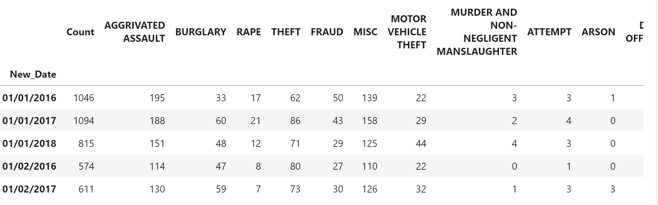

# **Question 1:**

## Is there an increase in crime during major shopping holidays?

## Statistical Tests

A student's T test was run comparing the number of crimes committed per day on holidays vs. non-holidays for the three US cities. This showed no statistically significant difference in crime for Austin and Los Angeles. P-scores were 56.7% and 37.1% respectively.

Chicago was found to have a small (4.43%) decrease in crime on holidays on average, with a P-score of 3.84%.

## Visualizations

The histograms below show the divided data distributions for all three cities. The difference between holiday and non-holiday crime counts can be seen on the Chicago figure. Since there are so few holidays, their histograms are difficult to discern. Plotting these again on a log scale helps to visualize the smaller data distributions.

The time series figure below provides another way to visualize Chicago crime in 2016. Data is quite noisy. There also appears to be a seasonal effect on crime, with an increase in the summer.

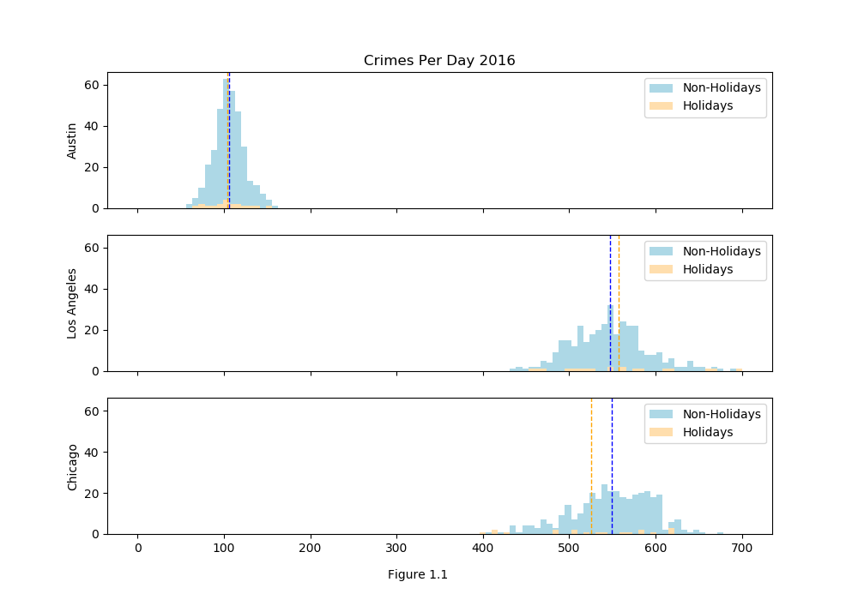

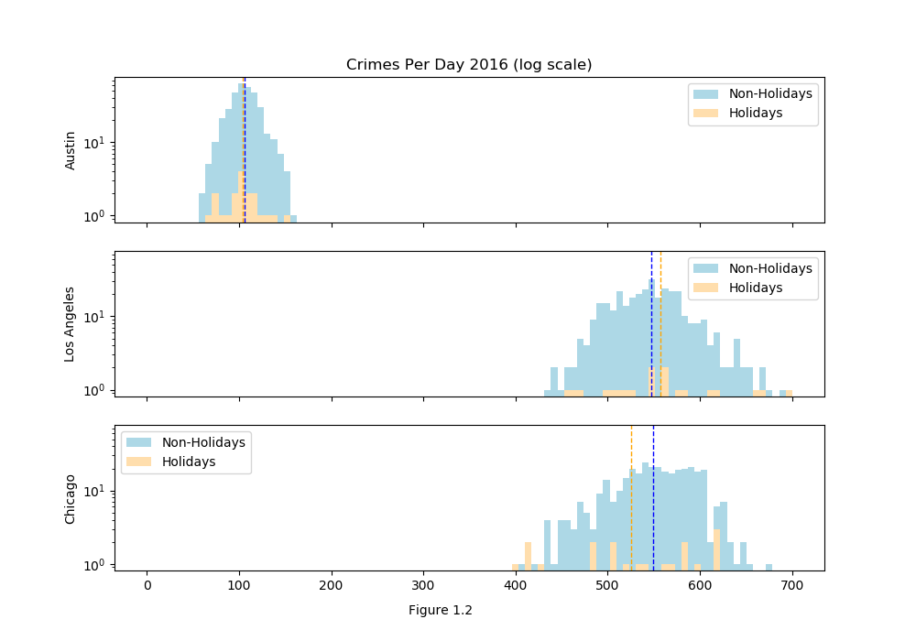

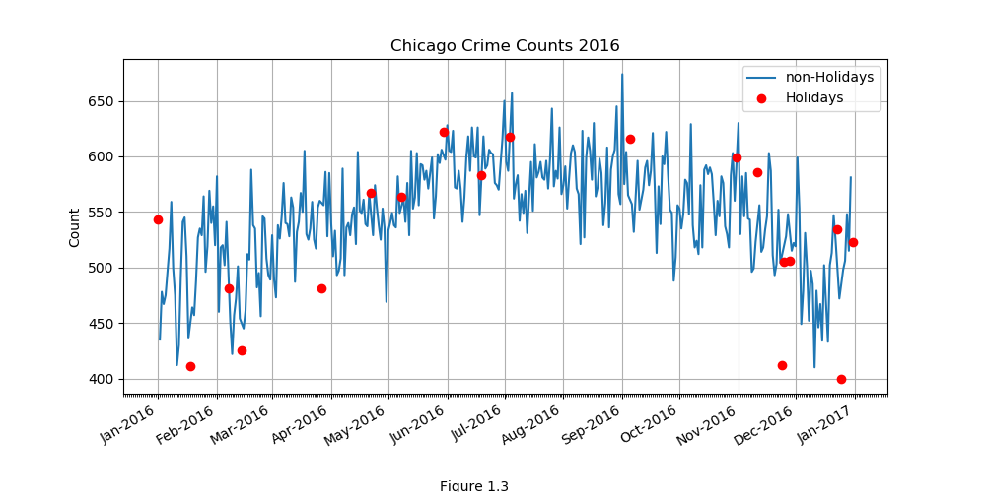

**Question 2:**

**Do cities with the least amount of crime experience an increase in crime that is more than noticeable during major shopping holidays?**

## Q2. Read in the csv file grouped by date with a count of crime type for each city

## Q2. Analysis

To measure the rate of crime in each city we calculated the crime per capita of each city and then also compared it to the total crime in each city. Comparing the data in FIG 2.1 shows us that the frequency of crime in the year 2016, per the sample set, is not necessarily correlated to the amount of crime, and population size in the given cities.

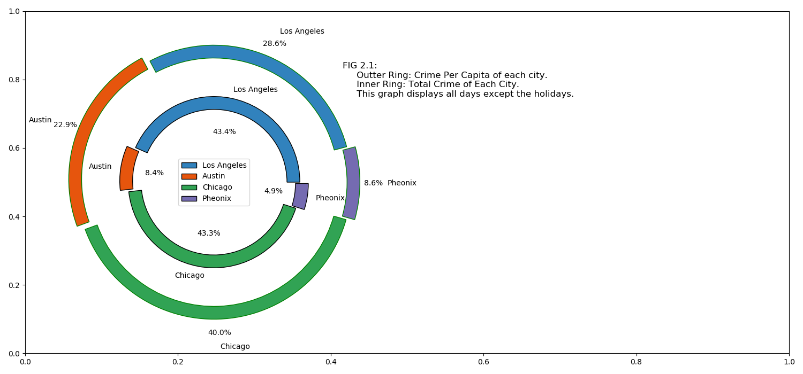

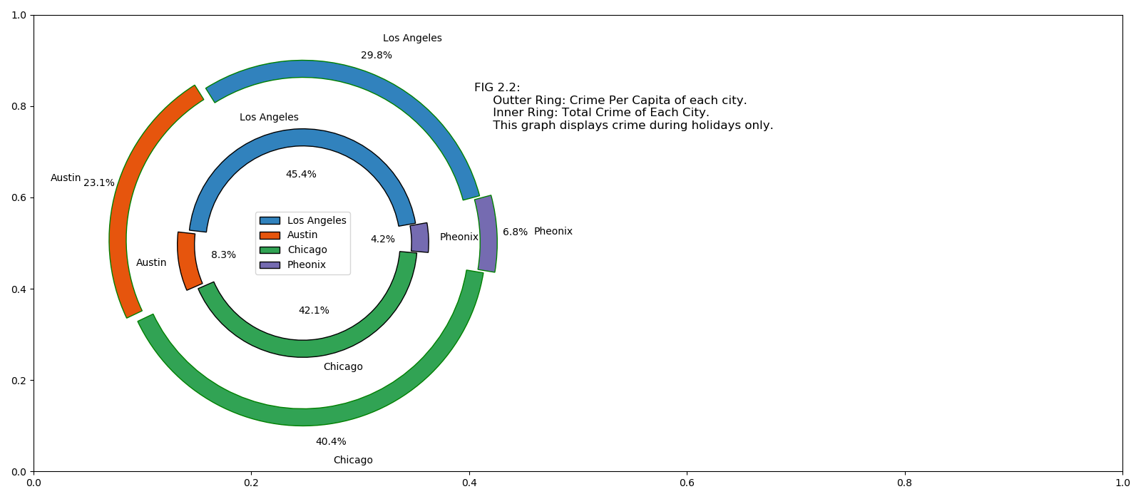

**Question 3.1:**

**Which holiday does crime more frequently occur on during major shopping holidays?**

**Use the data from 3 cities: Austin, Los Angeles and Chicago**

* **Chart 1: Stacked bar chart using total crime count and major shopping holiday.**
* **Analysis 1: We can determine which major shopping holiday has the most occurrence of crime.**

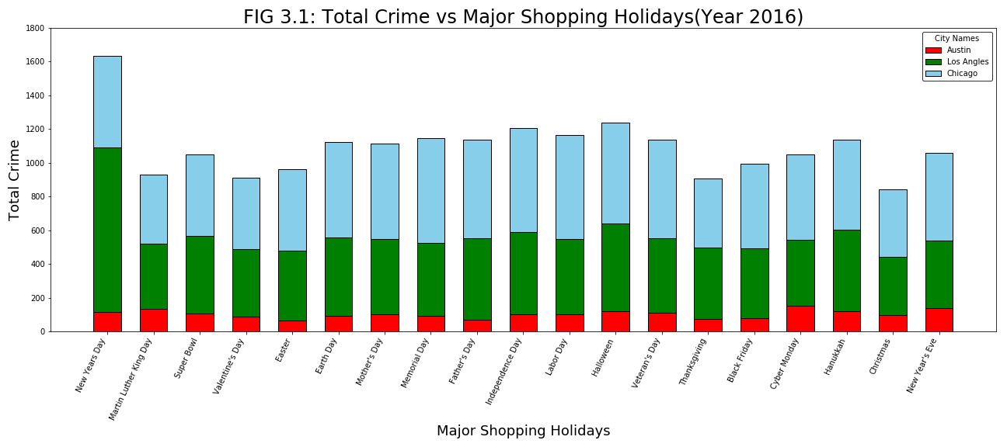***Observation:***

We consider crime data from 3 cities for the 18 major holiday shopping days for the year 2016. By observing the Total crime vs Shopping holiday stacked bar chart (FIG 3.1), we can conclude that most of the crimes occurred on New Year’s Day as compared to Christmas, Thanksgiving Day, or any other holiday. This could be due to Christmas being a religious holiday or Thanksgiving Day being a time where most families stay home Holidays such as Martin Luther King Day or Valentine’s Day have a considerably lower crime rate because they are relatively minor holidays compared to other holidays such as Labor Day, Independence Day, or New Year’s where many shops are still open.

If we observe individual cities, in Los Angeles, the maximum occurrences of crime occurred on New Year day as compared to all other major holidays. If we observe the data from Chicago, more crimes occurred on most holidays as compared to the other cities. Austin, in general, has significantly less occurrences of crime on every single holiday compared to the other cities, which may be due to the considerably lower population in Austin as compared to other cities.

**Question 3.2:**

**Which crimes are more prevalent during major shopping holidays?**

**Use the data from 3 cities: Austin, Los Angeles and Chicago**

* **Chart 2: Stacked bar chart 1: Holiday crime with crime type on x-axis vs crime count for each individual crime type.**[**¶**](http://localhost:8888/notebooks/Project/Minal_Project1/Project_1_crime/crime_by_date_revised/final_data_analysis_Minal.ipynb#Chart-2:-Stack-bar-chart1:-holiday-crime-with-crime-type-on-x-axis-vs-crime-count-for-individual-crime-type.)
* **Analysis 2: We can determine which crimes are most prevalent during each major shopping holidays**

**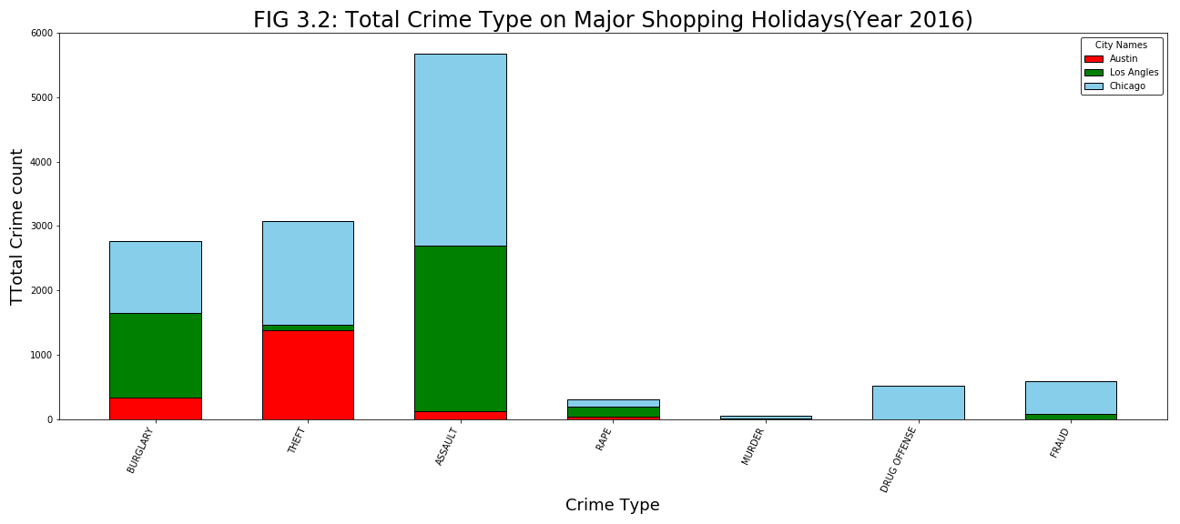*****Observation 2:***

By observing the total individual crime type stacked plot (FIG 3.2) on the same 3 cities during shopping holidays only, we can conclude that the most common type of crime is assault followed by theft. Assault’s prevalence is almost double that of the other crimes. If we compare the cities, we find that Chicago and LA follow the same trend with the prevalence of assault being the highest compared to other crimes however, in Austin, the most common crime type is theft instead of assault. This may be because Austin has a significantly lower population than the other cities, which results in assault being less likely compared to theft from stores or other institutions. Los Angeles has a significantly smaller theft rate as compared to other cities, which could be because Los Angeles is in California, which has the greatest economy out of all the states in the USA, which results in more money being able to go towards better security at homes, stores, and institutions, preventing theft. On the other hand, this cannot prevent burglary or assault as easily, which explains the significantly higher rates of burglary and assault in Los Angeles as compared to other crimes.

**Question 4:**

**Do the holidays have an impact on crime location?**

**Use the data from 2 cities: Chicago and New York City**

* **Chart 1: Google symbol map using crime count by location description during major shopping holiday and non-major shopping holidays.**
* **Chart 2: Heatmap using crime count by location description during major shopping holiday.**
* **Analysis 1: We can determine if there is a trend in location with most occurrence of crime during major shopping holidays.**
* **Chart 2: Bar chart using crime count by location description during major shopping holidays and non-major shopping holiday.**
* **Analysis 2: We can determine which location type has the most occurrence of crime.**

**Chicago Crime by Location 2016**

Chicago Holiday Crime 2016

Chicago Non - Holiday Crime 2016

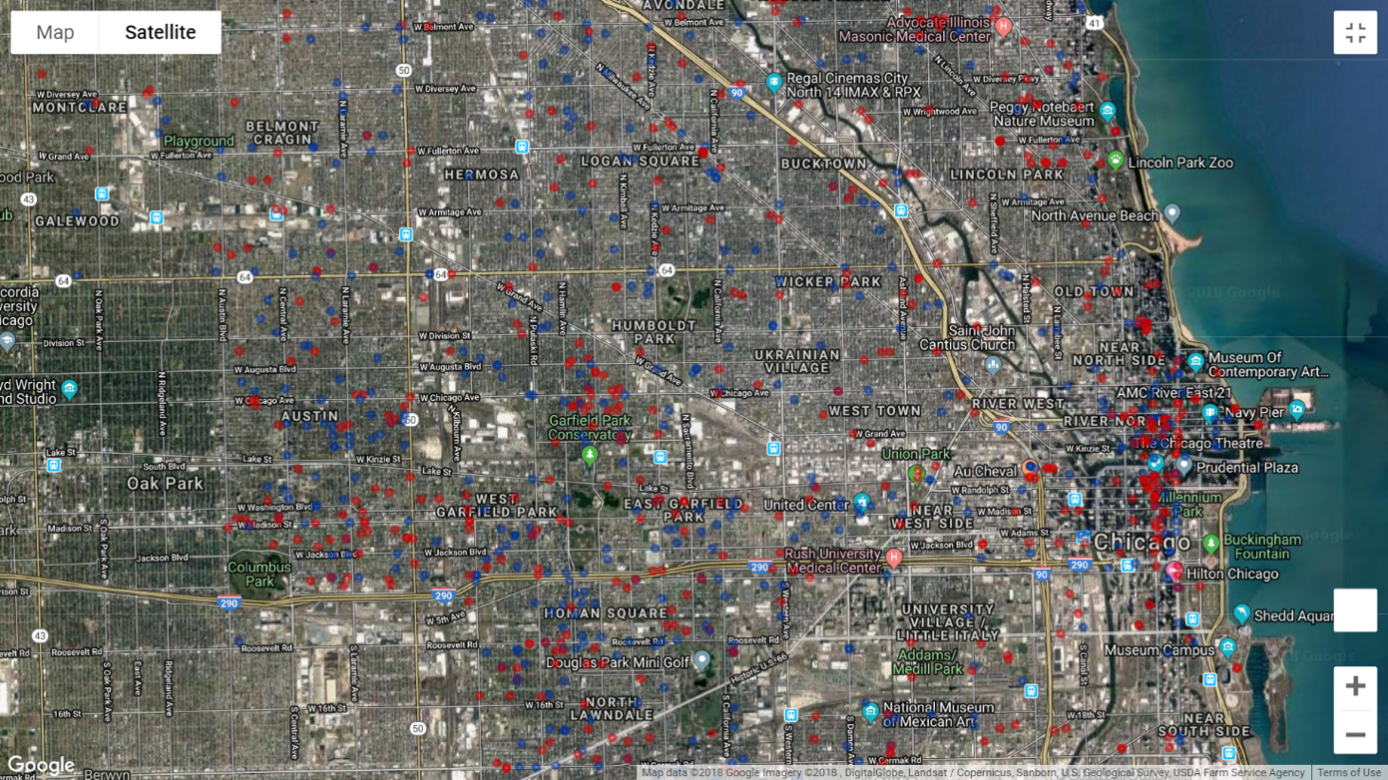

**Chicago Crime by Location (Holidays) 2016**

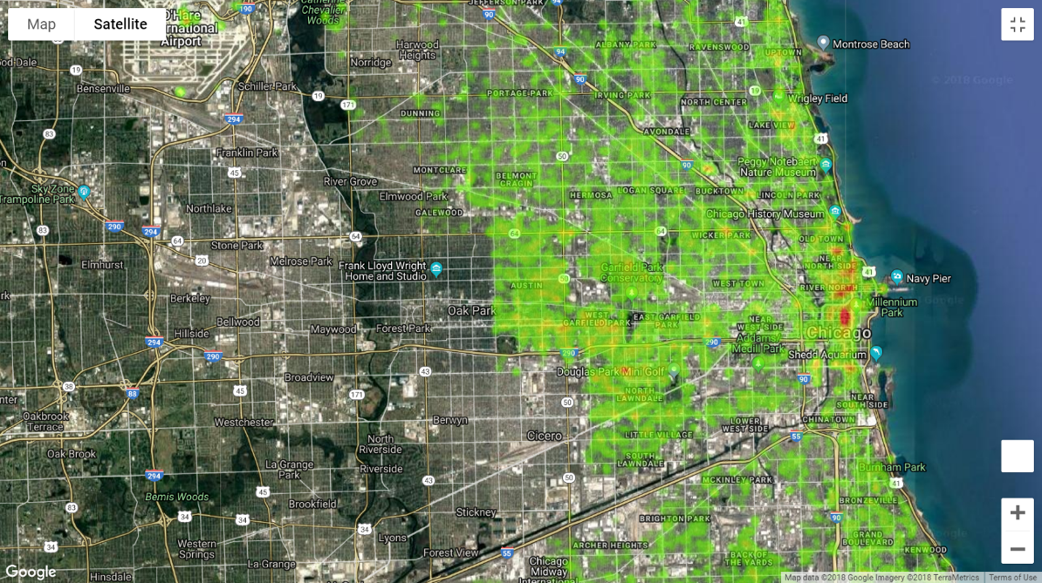

**Chicago Crime by Location (Non-Holidays) 2016**

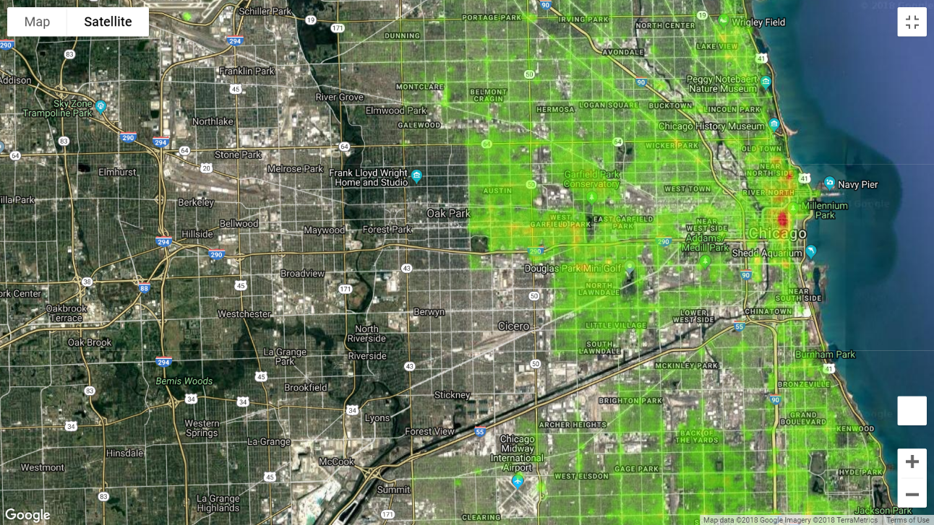

*Observation 1:*

We consider crime data from Chicago major shopping holidays for the year 2016 because Chicago has full location by date crime reporting. Additionally, Chicago has the highest crime per capita in the dataset. By observing the crime Heat Map, we do not notice a trend in crime location during major shopping holidays. The location and concentration of crime during major shopping holidays looks similar to the crime location and concentration during non-major shopping holidays. Therefore, it is likely that other demographics creating noise in the dataset are better explanatory factors for crime location.

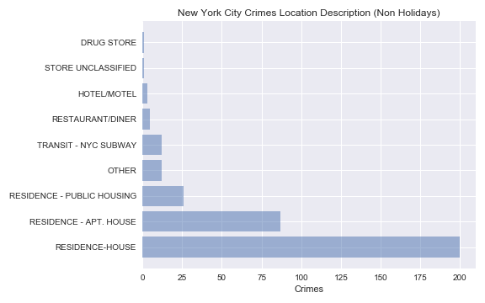

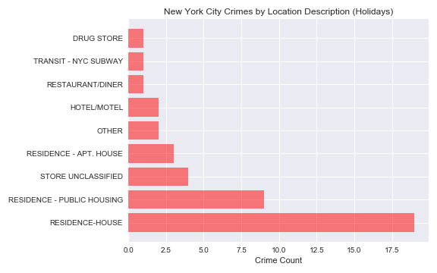

*Observation 2:*

We consider also consider crime data from New York City major shopping days and non-major shopping holidays for the year 2016 because New York City has full location by date crime reporting. Additionally, New York City has a large population size which is helpful for sampling. By observing the Crime by Location bar charts, we can conclude that most of the crimes occurred at a residence during both major shopping holidays and non-major shopping holidays. We do not observe a holiday impact on crime location. Lastly, the zoomed in image of the NYC heat maps shows evidence of reporting bias. Note the NYC Police Department is a location with a high crime count. This is likely because the police departments use these coordinates when the accurate address is unavailable and

**P and T scores :**

T Austin = -0.573

T Austin = 56.7%

T LA = 0.8958879334012444

P LA = 37.1 %

T Chicago: -2.078106931167499

P Chicago: 3.84%

Chicago average difference: -23.8 crimes per day

Chicago average % difference: -4.43 %

**Conclusion**:

Given our data set we were not able to prove if there was any correlation between an increase in crime during major shopping holidays.

**Errors in Data Analysis:**

* Variable Types when merging data frames for all cities.
* Inconsistent categories between cities. Some has hundreds.
* Struggles with heat map